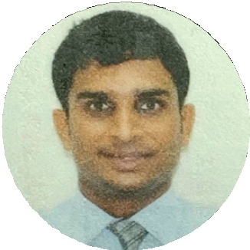

# My Contact

 [madhukars31@gmail.com](mailto:madhukars31@gmail.com)  +917718047894

Dombivli (E),Mumbai,Maharashtra

# Hard Skill

**Over a Decade of Experience in Hospitality and Goverment Projects.**

**Managed 3 Projects of MbPT (Mumbai Port Trust / Authority) in PPP Model.**

**Excellence & Higher Level of Achievements in Hospitality as F&B Professional in 5-star Hotels.**

**W-set Level 2 Awards in Wines & Spirits.**

**Awards in Indian Sommelier Championship.**

**Specialized in Banquet Operation & Sales.**

**Monitored New Restaurant Franchise Set-up & Operations. Analyzed Financial accounting.**

**Business valuation.**

# Soft Skill

**Observation Decision making Communication Multi-tasking**

# Education Background

***Bsc Hospitality in Hotel Management and Catering Technology***

Mastered in Hotel Operations and Food and Beverage Skills.

Completed in 2013

Holy Angels Education Society Completed in 2009

MADHUKAR SHETTY

# About Me

Dedicated and detail-oriented with 6 years of experience in Hospitality and Food and Beverage industry . Monitored Government Tenders and projects based on PPP model for over 4years.. Specialized in Operations and Marketing in Hotels, Restaurants and in New Government Tender based projects.

# Professional Experience

## Bayview lounge pvt ltd , Seapride pvt ltd and Kanhoji Angre island and Resorts pvt ltd

### 2019 – 2022

**Key responsibilities:**

**Liasioning of Mumbai Port Trust Project with Licensed Liasioning architect .**

**Consent to establish and Consent to Operate from MpCB Procuring Permissions From like CRZ clearance from MCZMA, Environmental clearance From MOEF and Fire NOC , Cc , O/C from Mumbai Port Trust MbPT.**

**Amending Architectural and Structural aspects and Drawings according to State or Local authorities as per National Building Code(NBC) and Development Control Regulations(DCR)**

**Look at recent financial performance and identify trends. Prepare reports on the above information and communicate the insights of these reports to the broader business.**

**Consult with the management team to develop long- term commercial plans.**

**Suggest budgets and improvements based on the above information.**

## U2M Udupi to Mumbai pvt ltd.

Key responsibilities:

Explored and Identified Statewide Food Trends and helped create a Brand with great Fast Dine-in Experience.

Conceptual Based Branding and Marketing with Kitchen Designing to Curating Food Menu .

Human Resources Management.

Monitered and Maintained High Quality of Food and standardisation of Taste in different Outlets.

Explored various investment opportunities to create a Brand into Franchise Module.

## The OBEROI Hotels and Resorts

### 2014 – 2019

Key responsibilities:

The BELVEDERE ,a business club where we endeavour to provide the right atmosphere for Leaders of Commerce and Industry.

Curated 6 Course Gourmet Menu with Wine and Spirit Pairing with Michelin Star Chef Vineet Bhatia At Modern Indian Restaurant ZIYA

Opened a Cocktail Bar With U.K's Top Mixologist Andrew Pearson Called EAU BAR.

Managed High Level of Service Standards in Restaurant and

Banquet Operations.